UBND THÀNH PHỐ HỒ CHÍ MINH  TRƯỜNG CAO ĐẲNG LÝ TỰ TRỌNG  THÀNH PHỐ HỒ CHÍ MINH | CỘNG HÒA XÃ HỘI CHỦ NGHĨA VIỆT NAM  Độc lập – Tự do – Hạnh phúc

TỜ TRÌNH
Về việc xin báo cáo nội dung ghi trên Website tiếng Anh

LY TU TRONG COLLEGE
HO CHI MINH CITY
INTRODUCTION
Established in 1986, Ly Tu Trong College of Ho Chi Minh City (LTTC) is one of the major public schools in Ho Chi Minh City which has the reputation for training quality of human resources to meet the demand of the workforce serving the socio-economic of the city and nationwide.
Owning a total area of 50,874m2, LTTC has an extensive green peaceful campus providing for learning, sports and entertainment for more than 10,000 students.
LTTC, with its 40 majors, offers students a wide range of professional programs specialized in Engineering, Economics and English. With well - qualified teaching staffs in sufficient quantity, LTTC commits to bring students high quality courses with reasonabletuition.
HISTORY

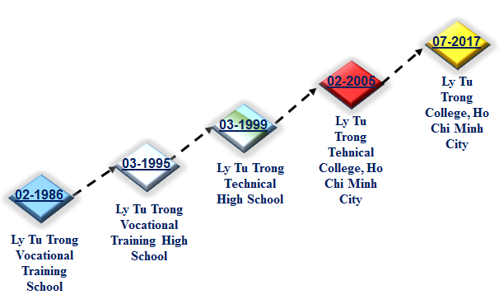

VISION
To develop Ly Tu Trong College of Ho Chi Minh City into an applied university of nation and become a multi - level and multi - disciplinary education institution with modern and advanced orientation in order to have a worthy position in higher education of Viet Nam and region, to meet the needs of high quality human resources for a special city and for industrialization and modernization of the country.
By 2020, Ly Tu Trong College of Ho Chi Minh City will become a high qualify training institution of country and meet ASEAN standards.
MISSION
Ly Tu Trong College of Ho Chi Minh City:
- Is a place to train human resources with prestige and high quality to meet the needs of society, enterprises and contribute to the process of industrialization and modernization of Ho Chi Minh City and the country.
- Is a place to combine training with the research and transfer of scientific research results in the field of professional training and technology for society
KEY VALUE OF LTTC OF HCMC
Knowledge – Creativity – Development – Sustainablility
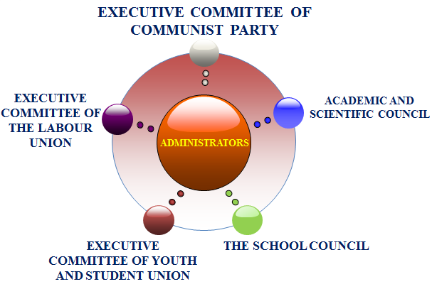
ORGANIZATION STRUCTURE

DEPARTMENTS
- Organization - Administration
- Admission - Training
- Planning and Finance
- Equipments and Materials
- Politics and Students
- Examinatio and Quality assurance
- Scientific management - International coorporation
- Facility management - Service
- Inspection – Legislation
FACULTY
Faculty of Mechanical Technology
The faculty has 32 teachers (over 70% of postgraduate level). There are over 2000 students studying at the faculty. 100% of students have jobs after graduation.
The faculty has trained high quality human resources to meet the needs of business and societ. Students are trained in a professional environment with a team of experienced teachers, practicing on modern equipments.
Faculty of Electrical - Electronics Technology
The faculty was established in 1989 and has been continuously developing for more than 28 years. With a team of 40 teachers (over 80% of post graduate level) with high profession, has a system of practical laboratories that are well invested and modern, training for 2500 students. 100% of graduates of the faculty have stable work in enterprises across the country.
Faculty of Information Technology
The faculty has 30 teachers (over 70% postgraduate level), 20 computer rooms are invested with synchronous and high configuration, training for nearly 1500 students.
In IT Olympiads, ACM/ICPC student programmers, our students always achieve high rankings. Most of the graduates have jobs that are consistent with the areas being trained by the faculty.
Faculty of Automotive Technology
Founded in 1989, the faculty has 30 teachers (over 90% of postgraduate level). The faculty has 16 practice workshops with full equipment.
The faculty is training 2000 students. 100% of graduates have professional jobs in companies such as Toyota, Mercedes, BMW… are highly rated on practial skills and professional attitude.
Faculty of Garment Technology – Fashion
The faculty is training high quality human resources in skills and workmanship. The faculty has 20 teachers (over 70% of postgraduate level) have much experience.
The workshops are fully equipped, always supplemented, renovated, suitable with the development of the garment industry. 100% of students graduated have suitable professional jobs.
Faculty of Thermal Technology
The faculty is a place to train and provide human resources specialized in thermal technology for the city and the whole country.
The faculty has skilled teachers, dedicated, always adding new knowledge. The graduates have the ability to consult, install, maintain, repair and operate systems and equipment in the field.
Faculty of Economy
The faculty specialized in training small and medium enterprises (SMEs) management, Corporate Accounting, Corporate Finance.
Graduates are able to take up positions in enterprises, finance companies, credit institutions, domestic and foreign banks.
Faculty of Foreign Language
The faculty is training human resources capable of using foreign languages good communication skills, highly adaptable to the international work environment and technology transfer. Graduates are easily to have jobs in the trend of globalization and deepening international integration of the country
CENTERS
- Information center - Library
- Ly Tu Trong Training Center
- Enterprise Relation Center
- F+U Sachsen Center of HCMC
- Health care Center
STAFFS - TEACHERS – EMPLOYEES
By 2017, LTTC have 23 unit: 9 departments, 9 faculties, 5 centers.
Total: 332 employees
Total 200 lecturers with 04 PhD., 167 Master, 83% Graduated
LEVEL OF TRAINING PROGRAMS
Advanced associate degree (2.5 yrs)
Professional associate degree (2 yrs)
Professional associate degree (9+4 yrs)
Technician diploma (9 + 3 yrs)
Technician diploma (12 + 1 yrs)
In - service university degree (4 yrs)
Transfer university degree (1.5 yrs)
SECTOR OF TRAINING
NO. | ASSOCIATE DEGREE
1 | Applied Information Technology
2 | Website Design
3 | Computer Engineering & Technology
4 | Computer Programming
5 | Network Security
6 | Computer Network Administration
7 | English
8 | Business Finance
9 | Business Accounting
10 | SME Business Administration
11 | Mechanical Engineering Technology
12 | Manufacturing Technology
13 | M&E Equipment Maintenance
14 | Maintenance of Industrial Equipment System
15 | Metal Cutting Engineering
16 | Automotive Engineering
17 | Electrostatic Coating Technology
18 | Thermal Engineering Technology
19 | Cooling Equipment Technology & Air Conditioning
20 | Operation and Maintenance of Refrigeration Equipment
21 | Refrigeration Equipment Installation
22 | Electronics – Electrical Engineering Technology
23 | Consumer Electronics
24 | Consumer Electric
25 | Electrical Installation Work
26 | Electrical Installation Technique & Industrial Control
27 | Telecomunications Technical Station
28 | Optical Transmission Technology and Radio
29 | Control Engineering Technology and Automation
30 | Automation Equipment Repair
31 | Mechatronics Engineering Technology
32 | External Network Techniques and Terminal
33 | Industrial Electronics
34 | Industrial Electric
35 | Garment Technology
36 | Fashion Design
37 | Garment - Fashion
38 | Veston Garment Technology
39 | Civil Engineering

NO. | TECHNICIAN DIPLOMA
1 | Applied Information Technology
2 | Website Design
3 | Computer Hardware Engineering & Technology
4 | Computer Programming
5 | Network Security
6 | Computer Network Administration
7 | English
8 | Business Finance
9 | Business Accounting
10 | SME Business Administration
11 | Mechanical Engineering Technology
12 | Welding Technology
13 | M&E Equipment Maintenance
14 | Machine Tool And Manufacturing Technology
15 | Maintenance of Industrial Equipment System
16 | Metal Cutting Engineering
17 | Automotive Engineering
18 | Electrostatic Coating Technology
19 | Car Painting Techniques
20 | Thermal Engineering Technology
21 | Cooling Equipment Technology & Air Conditioning
22 | Operation and Maintenance of Refrigeration Equipment
23 | Refrigeration Equipment Installation
24 | Electronics – Electrical Engineering Technology
25 | Consumer Electronics
26 | Consumer Electric
27 | Electrical Installation Work
28 | Electrical Installation Technique & Industrial Control
29 | Telecomunications Technical Station
30 | Optical Transmission Technology and Radio
31 | Automatic Control Engineering Technology
32 | Automation Equipment Repair
33 | Mechatronics Engineering Technology
34 | External Network Techniques and Terminal
35 | Industrial Electronics
36 | Industrial Electric
37 | Garment Technology - Fashion
38 | Fashion Design
39 | Garment - Fashion
40 | Veston Garment Technology
41 | Civil Engineering

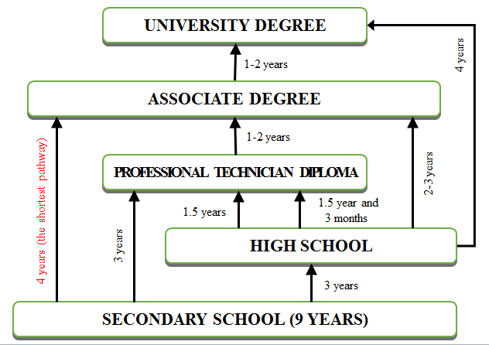
TRANSFER DIAGRAM

ADMISION
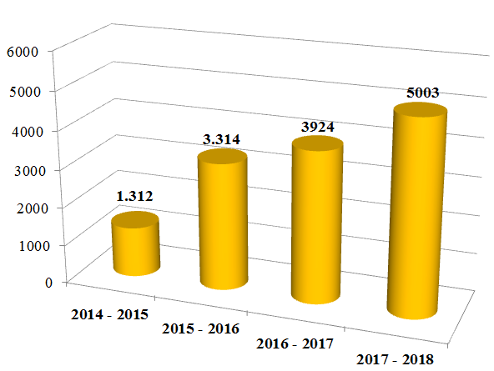

CAPACITY
ASSOCIATE DEGREE | 8.346
1. Foundation Science | 104
2. Mechanical Engineering | 1.870
3. Information Technology | 1.047
4. Electrical - Electronics Engineering | 1.838
5. Automotive Engineering | 2.241
6. Thermal Engineering | 630
7. Garment Technology - Fashion | 432
8. Economics | 184

TECHNICIAN DEGREE | 3.082
1. Foundation Science | 96
2. Mechanical Engineering | 286
3. Information Technology | 670
4. Electrical - Electronics Engineering | 577
5. Automotive Engineering | 735
6. Thermal Engineering | 318
7. Garment Technology - Fashion | 156
8. Economics | 244
INTERNATIONAL COOPORATION
The International Cooperation is considered as the first priority of the College to look for partners in the region as well as in the world to expand all forms of cooperation. To develop International cooperation, LTTC carries out various activities, such as:
- Organizing conferences, seminars, workshops
- Seeking schoolarships for students and staffs.
- Having Exchance Programs with foreign universities, institutes and organizations.
- Developing and enchancing intenational relations with: Kunsan University of Korea, Koje College of Korea, Cardiff Metropolitan University of UK…
About the international cooporation projects, from 2015 to 2017, LTTC successfully built 2 NGO projects, which was approved by the People’s Committee of Ho Chi Minh City, with the cost of 24.8 billions VNĐ:
- “Green Electrician” project is sponsored by Schneider Electric, DEG, ASSIST ASIA with 9.8 billions VND.
- “KONE Elevator and Escalator Training Center Construction - PROMPT” project that is sponsored by KONE Corporation, DEG, with 15 billions VND
CAREER OPPORTUNITIES


